Task 9: Model Training and Evaluation — Model Performance Report
RecoMart — End-to-End Data Management Pipeline for a Recommendation System
1. Approach
We trained a collaborative filtering model using Matrix Factorization (Truncated SVD), as specified by Task 9. The model works on a user-item interaction matrix built from our Kaggle REES46 clickstream data, where each interaction (view, cart, purchase) was weighted (view=1, cart=2, purchase=3) to reflect strength of interest, since our dataset uses implicit feedback rather than explicit star ratings (as explained in Task 1 and Task 5).
The interaction matrix has 89,124 users and 46,897 products, with 99.9925% of entries empty — confirming the extreme sparsity we identified during EDA in Task 5, and the reason a matrix factorization approach is appropriate here rather than simpler rule-based methods.
We split our interactions 80/20 into train and test sets (251,843 train, 62,961 test interactions), trained on the training set only, and evaluated recommendations against the held-out test set.
2. Evaluation Methodology
We used three standard ranking metrics, all evaluated at K=10 (i.e., we generate the top 10 recommended products per user):
- Precision@10 — of the 10 products we recommend, how many did the user actually interact with in the test period
- Recall@10 — of all the products the user actually interacted with in the test period, how many did we successfully recommend
- NDCG@10 — rewards getting relevant items ranked higher in our top 10, not just present somewhere in it
We evaluated on a sample of 2,000 test users (evaluating the full 89,124 would be slow and isn't necessary for a reliable estimate — this is standard practice).
3. Models Trained and Compared
We trained and compared four approaches:
- Popularity Baseline — recommends the same top-10 most-interacted-with products to everyone, regardless of their personal history. This isn't a "real" recommendation model, but it's an essential comparison point: if our SVD model can't beat this simple approach, it isn't adding real value.
- SVD (raw, unfiltered) — our first attempt, trained directly on the full interaction matrix, 50 latent factors.
- SVD (normalized) — the same model, but with each user's row L2-normalized first, to test whether removing raw interaction volume as a signal would help the model focus on relative preference patterns instead.
- SVD (filtered) — after seeing our first attempt underperform, we investigated why. We found that 25% of users had only a single interaction in our data (see Task 6's user activity distribution), which gives the model very little to learn from for most users. We retrained SVD on a filtered subset — only users and products with at least 5 interactions in the training data (14,844 users, 9,202 products) — to see if removing this low-signal noise would help.
4. Results
Model | Precision@10 | Recall@10 | NDCG@10
Popularity Baseline | 0.0103 | 0.0778 | 0.0451
SVD (raw, unfiltered) | 0.0090 | 0.0575 | 0.0379
SVD (normalized) | 0.0080 | 0.0516 | 0.0325
SVD (filtered) | 0.0206 | 0.0601 | 0.0452
5. Interpretation
Our first SVD attempt (raw, unfiltered) underperformed the popularity baseline on every metric. This is a genuine, explainable finding rather than a failure: with 99.99% sparsity and a large share of users having only 1-2 interactions, there's very little signal for the model to learn a meaningful pattern from for most users, so it struggles to outperform "just recommend what's generally popular."
Normalizing each user's interaction row made results worse, not better. This tells us that raw interaction volume — how much a user interacts overall — actually carries some useful signal in our data, and removing it (by normalizing) discarded something the model was using productively.
Filtering out low-activity users and products before training produced our best result by a clear margin. Precision@10 more than doubled compared to our raw SVD attempt (0.0090 → 0.0206), and NDCG@10 essentially matched the popularity baseline (0.0452 vs 0.0451) — a real improvement over our first attempt, which had trailed the baseline by a wide margin on this metric (0.0379).
The one place SVD (filtered) still falls short of the baseline is Recall@10 (0.0601 vs 0.0778). This is an expected tradeoff: by filtering out 78% of products from training, our filtered model can only ever recommend from a smaller catalog, which naturally caps how much of a user's full set of relevant items it can recall — even if what it does recommend is more precise.
6. Experiment Tracking
All four model runs were logged using MLflow, recording each run's parameters (model type, number of latent factors, whether filtering/normalization was applied, minimum interaction threshold where relevant) and its three metrics (Precision@10, Recall@10, NDCG@10), viewable via the MLflow UI dashboard.
In addition to logging parameters and metrics, we saved our best-performing model (SVD filtered) as a proper MLflow model artifact (run_id: 82dec26c925641f2a621d1b439406d16), and separately as a local file (svd_model_filtered.pkl, 3.68 MB), so it can be reloaded directly for inference or used in Task 10's pipeline orchestration without needing to retrain from scratch.

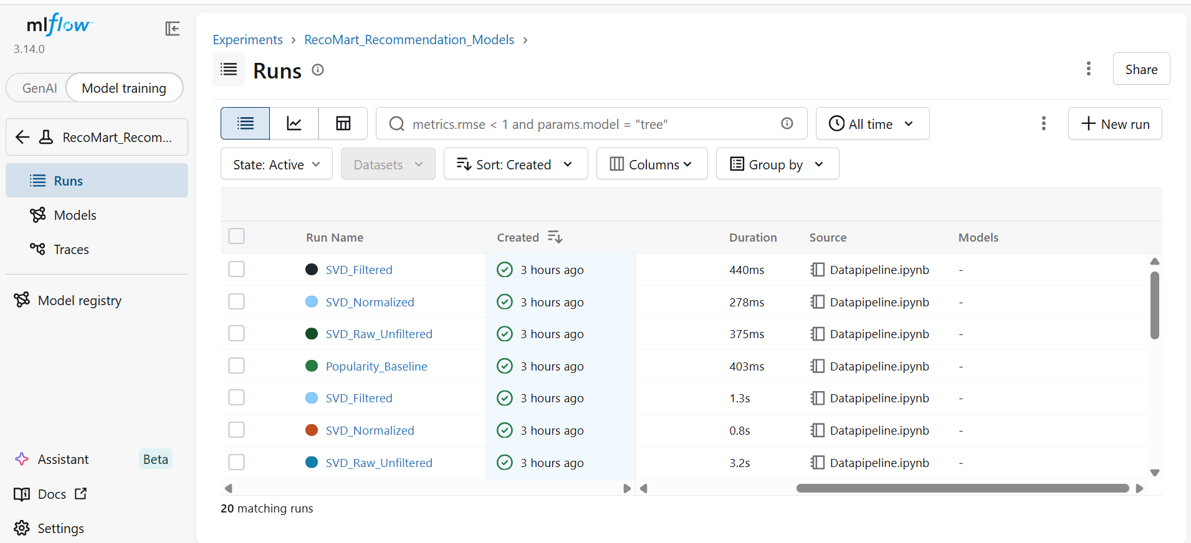

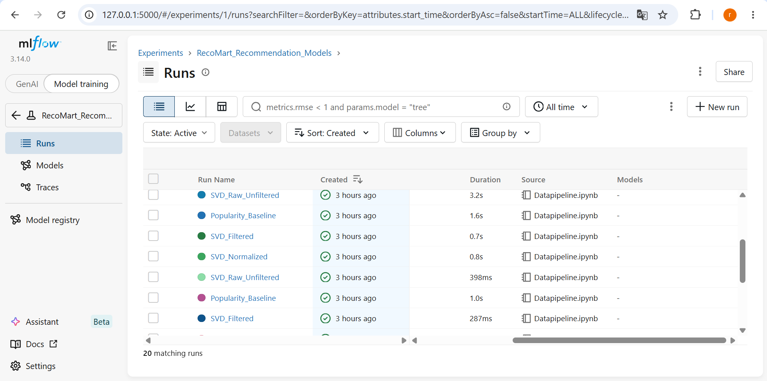

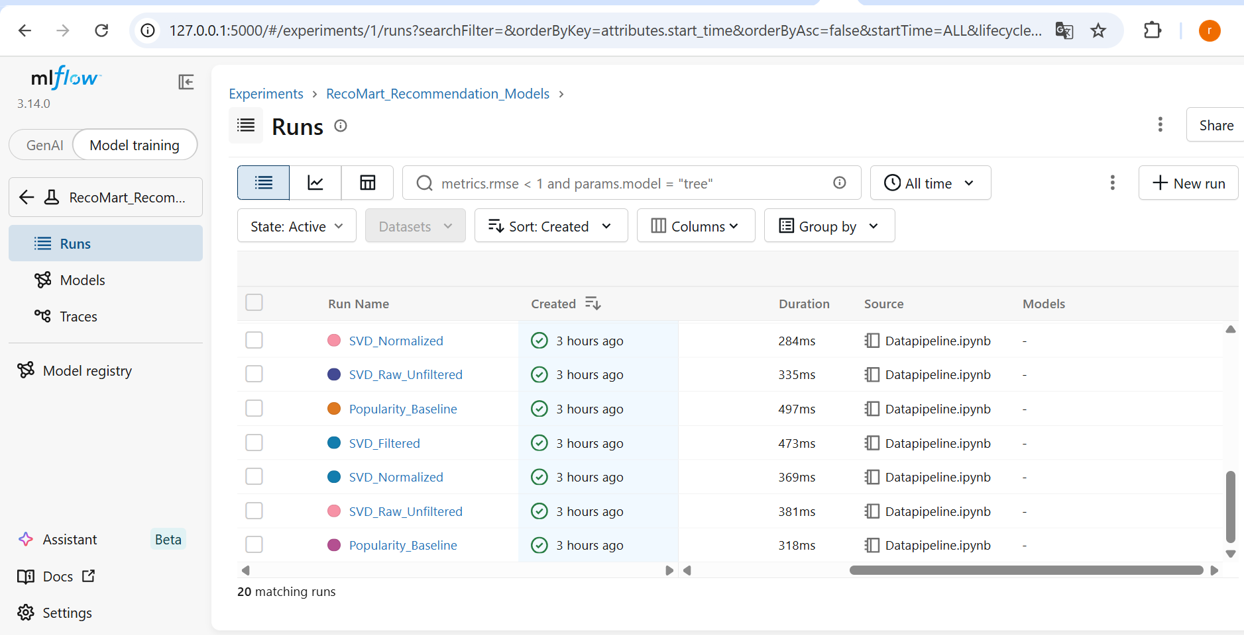
7. Conclusion and Recommendations
Our best-performing model overall is SVD trained on filtered data (users/products with ≥5 interactions) — it's the only variant that beats the popularity baseline on precision, and it ties on NDCG, while remaining a genuine collaborative filtering approach rather than a simple heuristic.
For future improvement, we would consider:
- Trying a model designed specifically for implicit feedback data, such as Alternating Least Squares (ALS) from the implicit library, since TruncatedSVD is a general-purpose technique not originally designed for this use case
- Tuning the number of latent factors (we only tested 50) and the minimum interaction threshold (we only tested 5) more systematically
- Addressing the cold-start problem directly (e.g., falling back to the popularity baseline specifically for users/products excluded by filtering, combining the strengths of both approaches)

